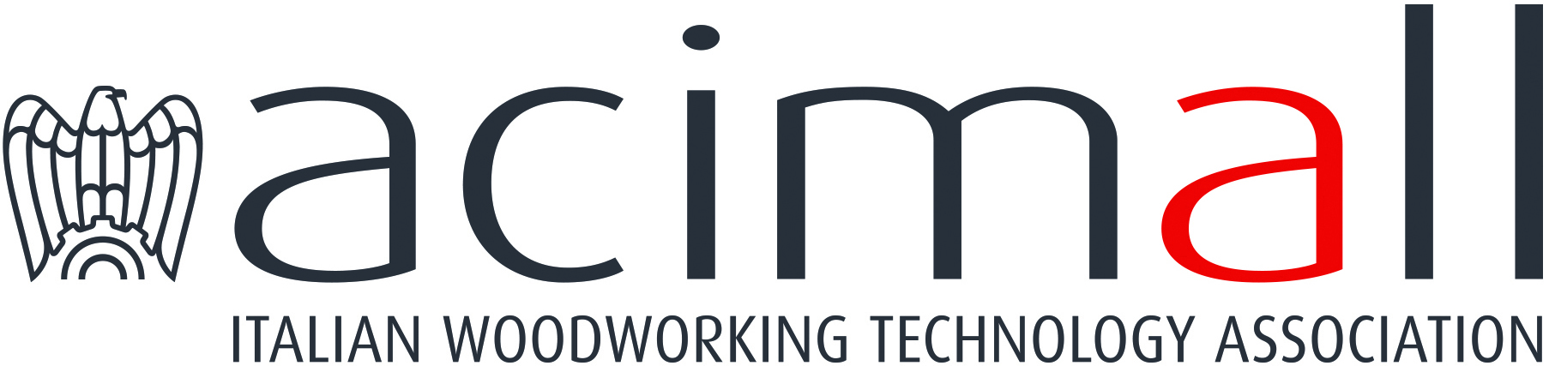 | Acimall  Centro Direzionale Milanofiori  Strada 1 - Palazzo F3  I-20090 Assago (Milano)  phone +39 02 89210200  fax +39 02 8259009  www.acimall.com  info@acimall.com | press office  May 5, 2025

ACIMALL: THE 2025 FINAL BALANCE INDICATES A STABLE TREND
IN THE WOOD AND FURNITURE TECHNOLOGY SECTOR

According to the data published by Acimall, the association of Italian manufacturers of woodworking machinery, the industry closed 2025 with a total production value of 2.398 billion euros, recording a minor reduction (1 percent) compared to the previous year.
The positive variation from the preliminary balance, as shown by Istat figures, results from a significant rally of export, combined with the positive trend of the domestic market, with both factors compensating the negative results initially expected.
Export reached 1.582 billion euro, down by 6.6 from the previous year, while sales on the domestic market amounted to 816 million euros, 15 percent more than in 2024. The positive trend of the Italian market is witnessed also by growing imports, which reached 284 million euro (plus 24.5 percent from the previous year).
The trade balance of the industry remains on the plus side, with a positive balance of 1.298 billion euros. The figures are positive also in terms of Italian market size, with an apparent value of 1.100 billion euros, up by 15.4 percent over 2025.

“Despite several critical situations – said Dario Corbetta, Acimall director – last year our industry was basically stable thanks to export, which account for 70 percent of total production, but most of all thanks to the positive trend of the Italian market, once again reaffirming its leading position on a global scale.
The Italian offer continues to be appreciated at home and abroad, remaining consistently in the high end of the market, focusing on top-notch technological solutions rather than price. This trend has been consolidating in the medium term and has supported a process of selection and elimination of some manufacturers, but ultimately, it identifies and strengthens an offer that will last over time”.

Although the task is challenging, the association has tried to figure out what might happen in the current year: “2026 is and most likely will be a tough year, due to the political situation and the war scenarios our companies are facing”, Corbetta concluded. “However, our manufacturers are working as intensively as usual, to consolidate their market shares abroad and to leverage the recovery of the Italian market, also driven by measures such as hyper-amortization. The most important even of the year – the exhibition Xylexpo, scheduled at Fieramilano Rho in Milan from 9 to 12 June – will definitely give more insights about the near future”.

For more information:

Luca Rossetti

+39 351 9098189 - press@acimall.com

